# CS 255 System Design Document Template

## UML Diagrams

### UML Use Case Diagram

### UML Activity Diagrams

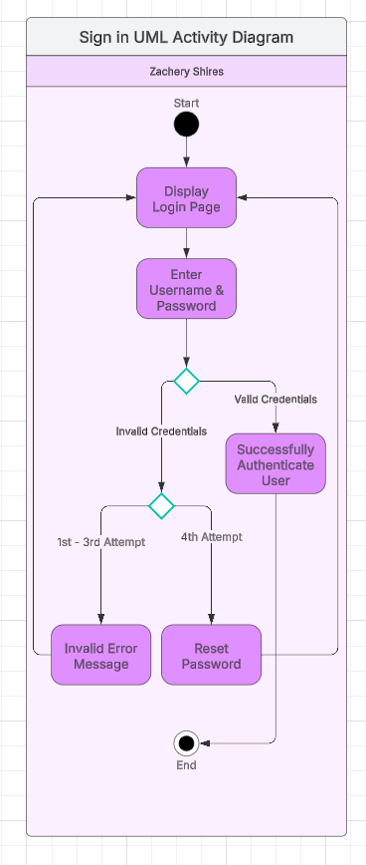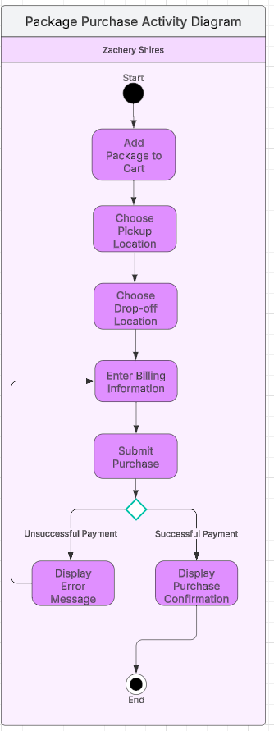

### UML Sequence Diagram

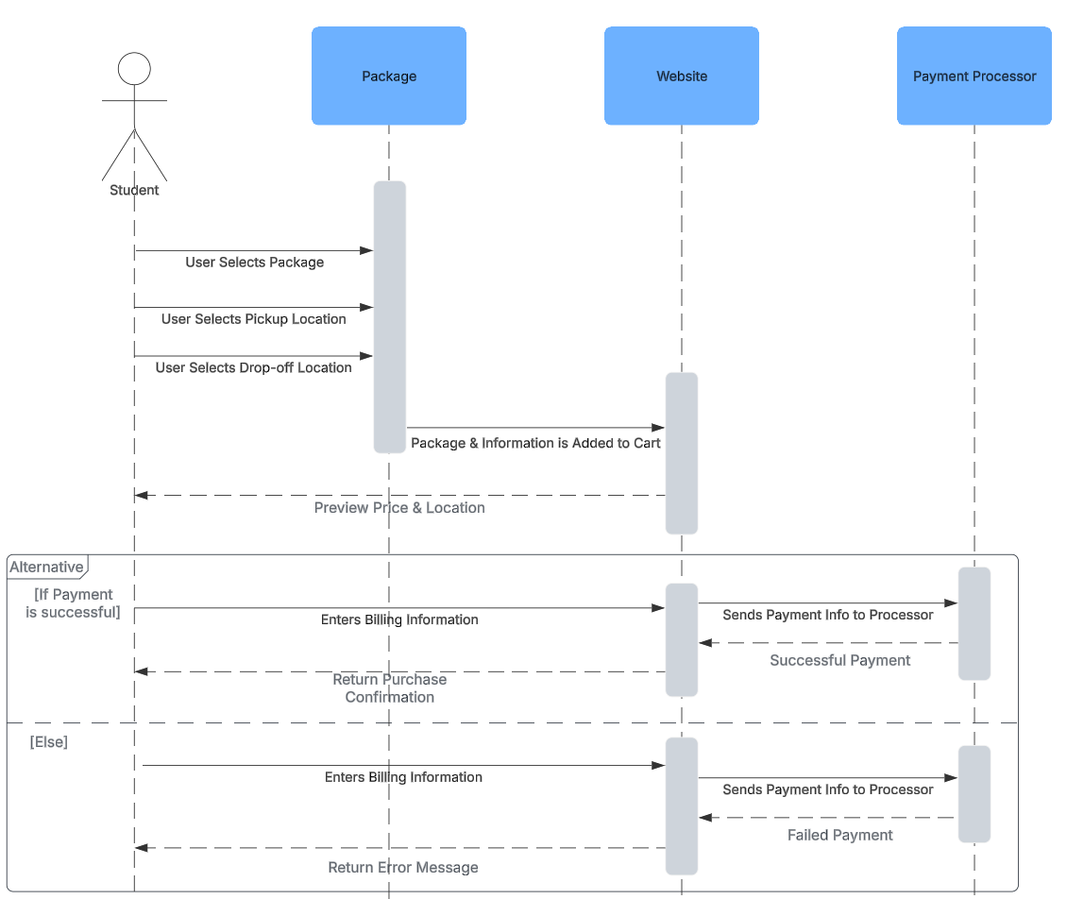

### UML Class Diagram

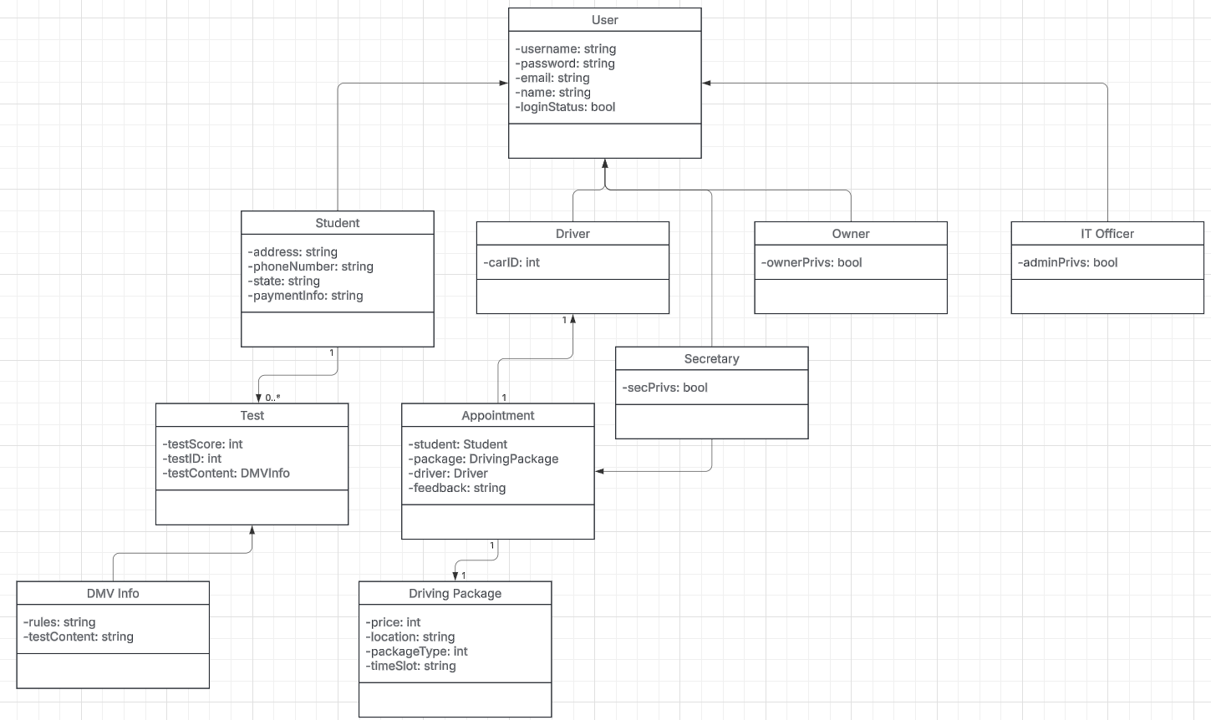

## Technical Requirements

* Hardware
  + Cloud-based web server
  + Client devices including:
    - Desktop
    - Tablet
    - Smart Phone
    - Laptop
* Software
  + Web application framework
  + Database management system
  + Security software
  + API for DMV connection
  + Supported browsers including:
    - Chrome
    - Firefox
    - Edge
    - Safari
* Tools
  + Integrated development environment
  + Frontend framework
  + Backend framework
  + Role-based access control for account management
* Infrastructure
  + High-speed internet connection for both the client and the company